Ideation Phase
Define the Problem Statements

Date | 31 January 2025
Team ID | LTVIP2026TMIDS81651
Project Name | Explore with AI: Custom Itineraries for Your Next Journey
Maximum Marks | 2 Marks

Customer Problem Statement – TravelGuideAI
To understand the user’s perspective, the team analyzed common challenges faced by travelers during trip planning. Many travelers struggle to create well-organized itineraries because they must search multiple websites, compare options, and manually plan their schedules.
Users often feel overwhelmed by the amount of information available online. They may miss important attractions, choose inefficient travel routes, or fail to balance sightseeing with rest and dining. This leads to stress and poor travel experiences.
Modern travelers expect quick, personalized, and reliable planning tools. However, most current solutions require manual effort and do not adapt to individual preferences.
Customer Problem Statement:
Travelers need a fast and intelligent way to generate personalized travel itineraries so they can save time, reduce stress, and enjoy a well-planned trip.
By understanding this problem from the customer’s point of view, the team designed TravelGuideAI to provide AI-generated itineraries tailored to user inputs such as destination and duration.
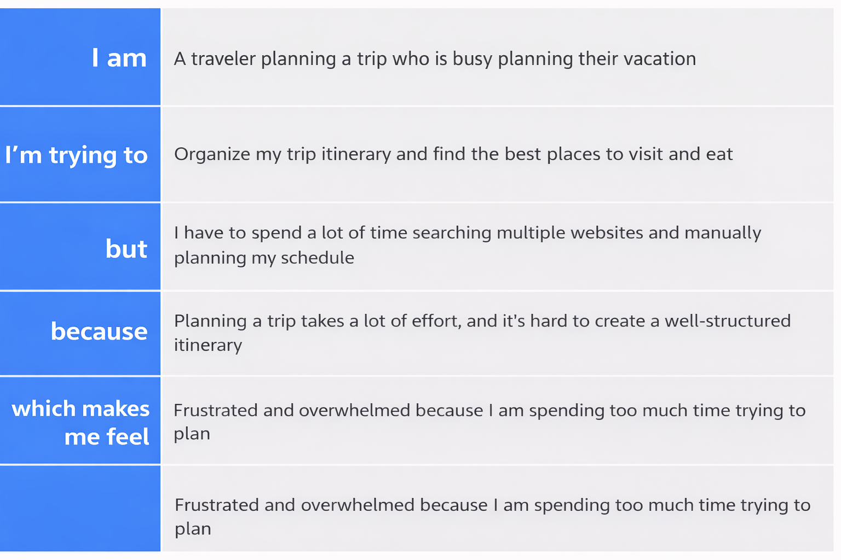
Reference: https://miro.com/templates/customer-problem-statement/

Problem Statement (PS) | I am (Customer) | I’m trying to | But | Because | Which makes me feel
PS-1 | A modern traveler who loves exploring new places | Create a personalized travel plan | must check multiple sources for ideas | There is no single smart planner | Overwhelmed and tired
PS-2 | A first-time traveler | Organize a smooth and enjoyable trip | I don’t know which places to prioritize | I lack travel knowledge and guidance | Uncertain and anxious

